**Automation Test on Demo Todo Application**

By: Olivia Meydina A.W

Current automation test are using Phyton and selenium.

Software needed to run this testing:

* [Firefox](https://www.mozilla.org/en-US/firefox/new/?product=firefox-3.6.8&os=osx%E2%8C%A9=en-US)

Used as the browser for testing

* [Notepad++](https://notepad-plus-plus.org/download/v6.8.6.html)

Used to write the automation code

* [Phyton 2.7.10](https://www.python.org/ftp/python/2.7.10/python-2.7.10.msi)

1. Installation and environment setup

* Download and install firefox and notepad++ by follow link above
* Download and install install phyton by follow link above
* Add phyton path (C:\Python27\;C:\Python27\Scripts\)in the environment variable

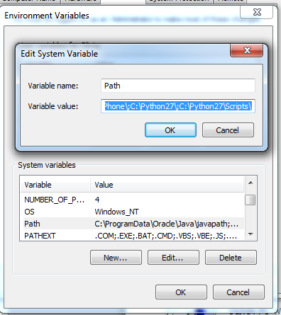

* After install the phyton and set the environment variable, copy “TodoTestAutomation” folder on D directory
* Open command promp and type “**pushd D:\TodoTestAutomation**” on cmd

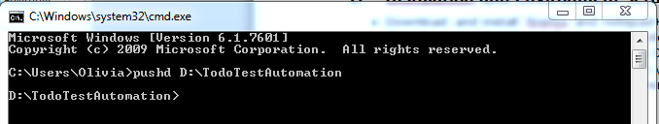

* Install pip by command **phyton get-pip.py** It will run the get-pip.py in TodoTestAutomation folder

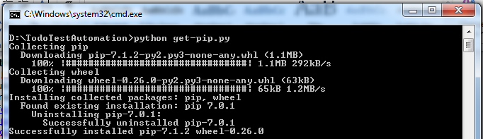

* Install virtual environment with command **pip install virtualenv**

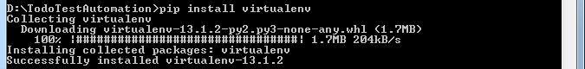

* Install Selenium with command **pip install selenium==2.40**

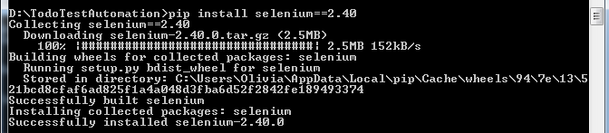

* Install nose with command **pip install nose**

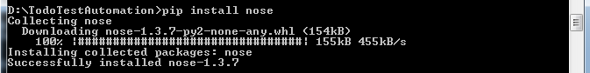

* Activate virtual environment



After set up the environment you can continue to the test.

1. Testing and Test Verification

Run the testing by insert command

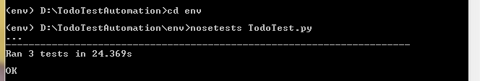

Source:

http://engineering.aweber.com/getting-started-with-ui-automated-tests-using-selenium-python/